Mini project

Title
TransitHub – Railway & Bus Management System using Flask, MySQL, HTML, CSS and JavaScript.

Aim:

The aim of the TransitHub Railway & Bus Management System is to develop a centralized web-based system for managing railway and bus transportation information, schedules, passengers, bookings, seats, payments, and live operational status.

Proposed Solution:
TransitHub solves these problems by integrating a web frontend, Flask backend, and MySQL database.
The system provides:
- Centralized storage of railway and bus information.
- Management of routes, stations and bus stops.
- Train and bus schedule management.
- Passenger and user management.
- Booking and seat management.
- Payment tracking.
- Dashboard statistics such as:
  - Active trains
  - Active buses
  - Today's bookings
  - Today's revenue
- Transportation status such as:
  - On Time
  - Delayed
  - Boarding
  - Departed
  - Arrived
  - Cancelled
The Flask backend retrieves information from MySQL and sends it to the dashboard, where it is displayed in a user-friendly format.
System Workflow
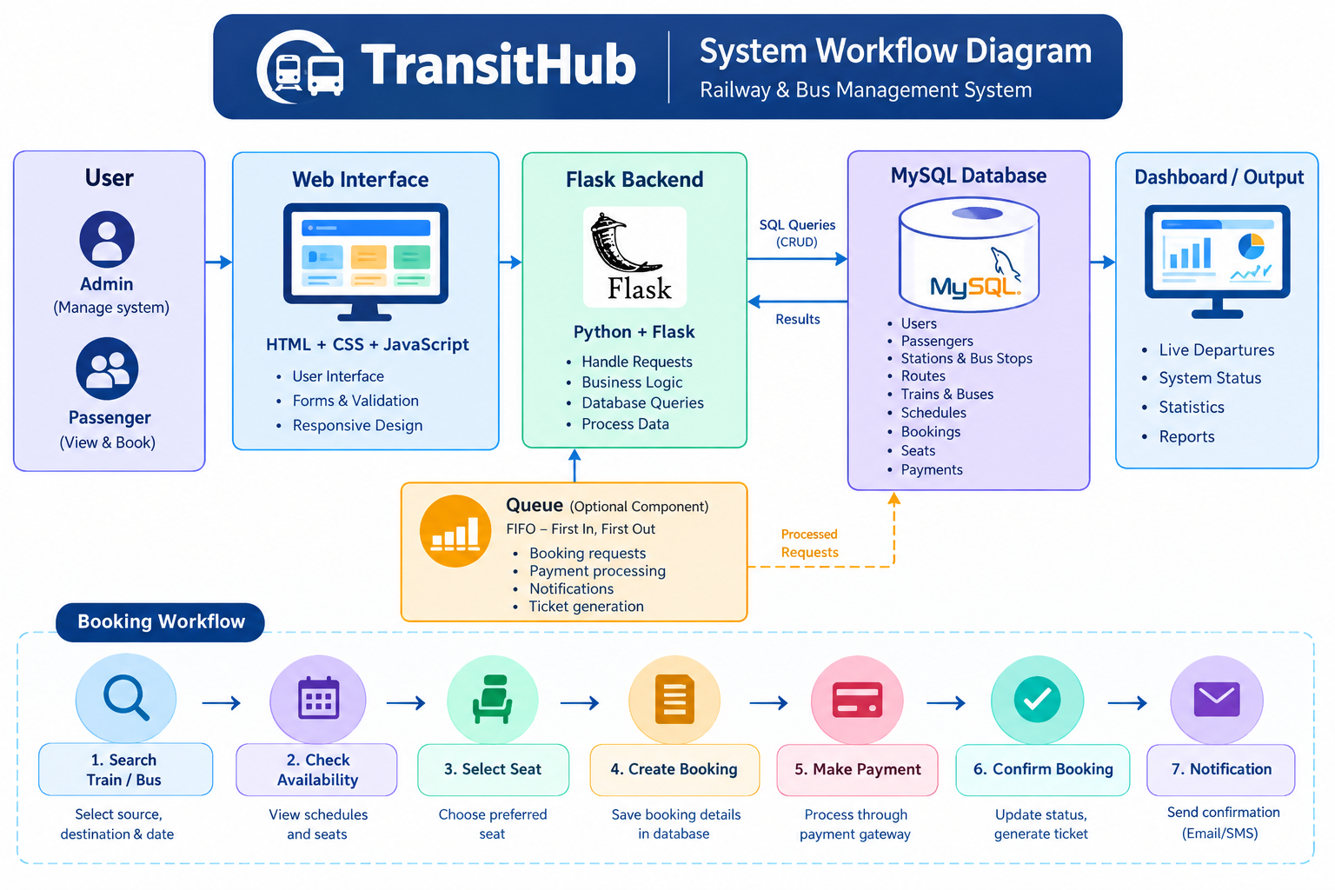
Database Design
Table | Purpose
users | Stores login/user information
passengers | Stores passenger details
stations | Stores railway station information
bus_stops | Stores bus stop information
routes | Stores train and bus routes
trains | Stores train information
buses | Stores bus information
schedules | Stores departure and arrival schedules
seats | Stores seat information
bookings | Stores passenger bookings
booking_seats | Connects bookings with seats
payments | Stores payment information
Technologies Used

Technology | Purpose
HTML5 | Structure of the web pages
CSS3 | Dashboard styling and responsive design
JavaScript | Dynamic frontend behaviour
Python | Backend programming
Flask | Web framework and API/backend handling
MySQL 8.0 | Relational database management
MySQL Connector/Python | Connects Flask with MySQL
python-dotenv | Loads database configuration from .env
Chart.js | Can be used for dashboard charts
VS Code | Development environment
ngrok | Temporary public access for demonstration

SQL Queries Used

- CREATE DATABASE
- USE DATABASE
- CREATE TABLE
- INSERT INTO
- SELECT
- UPDATE
- DELETE
- JOIN
- COUNT
- SUM
- GROUP BY
- WHERE
- ORDER BY
- NOT IN
- COALESCE
Program:

CREATE DATABASE transithub;
USE transithub;
CREATE TABLE users (
user_id INT AUTO_INCREMENT PRIMARY KEY,
name VARCHAR(100),
email VARCHAR(100) UNIQUE
);
CREATE TABLE routes (
route_id INT AUTO_INCREMENT PRIMARY KEY,
source VARCHAR(100),
destination VARCHAR(100),
transport_type VARCHAR(20)
);
CREATE TABLE trains (
train_id INT AUTO_INCREMENT PRIMARY KEY,
train_number VARCHAR(20),
train_name VARCHAR(100),
total_seats INT,
route_id INT,
FOREIGN KEY (route_id) REFERENCES routes(route_id)
);
CREATE TABLE buses (
bus_id INT AUTO_INCREMENT PRIMARY KEY,
bus_number VARCHAR(20),
bus_name VARCHAR(100),
total_seats INT,
route_id INT,
FOREIGN KEY (route_id) REFERENCES routes(route_id)
);

CREATE TABLE bookings (
booking_id INT AUTO_INCREMENT PRIMARY KEY,
user_id INT,
transport_type VARCHAR(20),
total_amount DECIMAL(10,2),
status VARCHAR(20),
FOREIGN KEY (user_id) REFERENCES users(user_id)
);
INSERT INTO routes
(source, destination, transport_type)
VALUES
('Mumbai','Pune','TRAIN'),
('Pune','Nashik','BUS');
SELECT * FROM trains;
SELECT * FROM buses;
SELECT * FROM bookings;
SELECT COUNT(*) AS total_trains FROM trains;
SELECT COUNT(*) AS total_buses FROM buses;

Output:
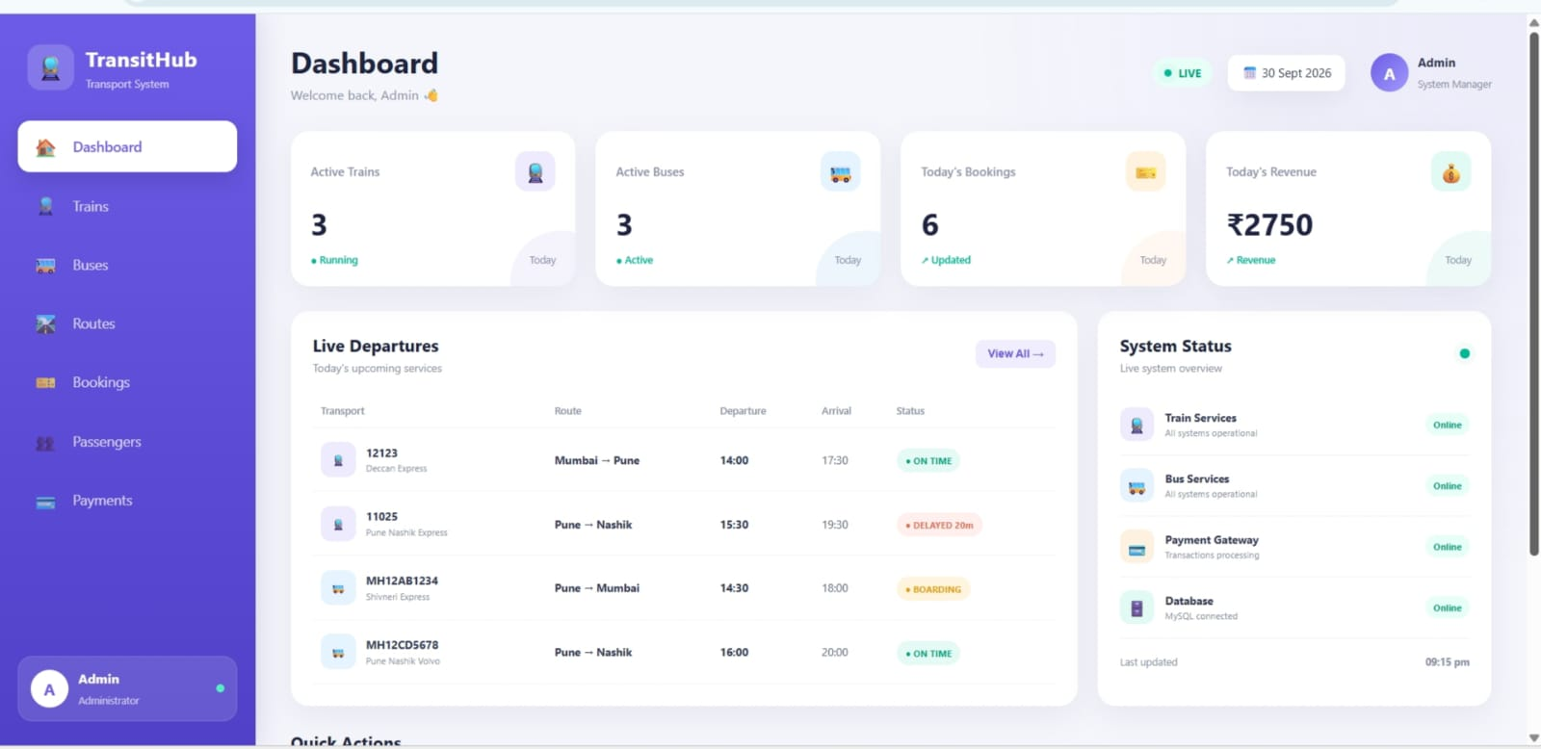

Conclusion

TransitHub provides a simple and efficient system for managing trains, buses, routes, schedules, bookings, and payments. It uses MySQL, Flask, HTML, CSS, and JavaScript to organize transportation data and provide an easy-to-use dashboard. The project demonstrates the practical use of DBMS concepts and SQL queries in a real-world application.

